Student Branch ExCom OFFICER TRAINING 2023-2024

IEEE MVSR SB conducted an Officer Training session for the newly selected ExCom members on 15th of July, 2023. The primary objective of this meeting was to elucidate the roles and responsibilities assigned to each member and to explain the functions of Student Branch.

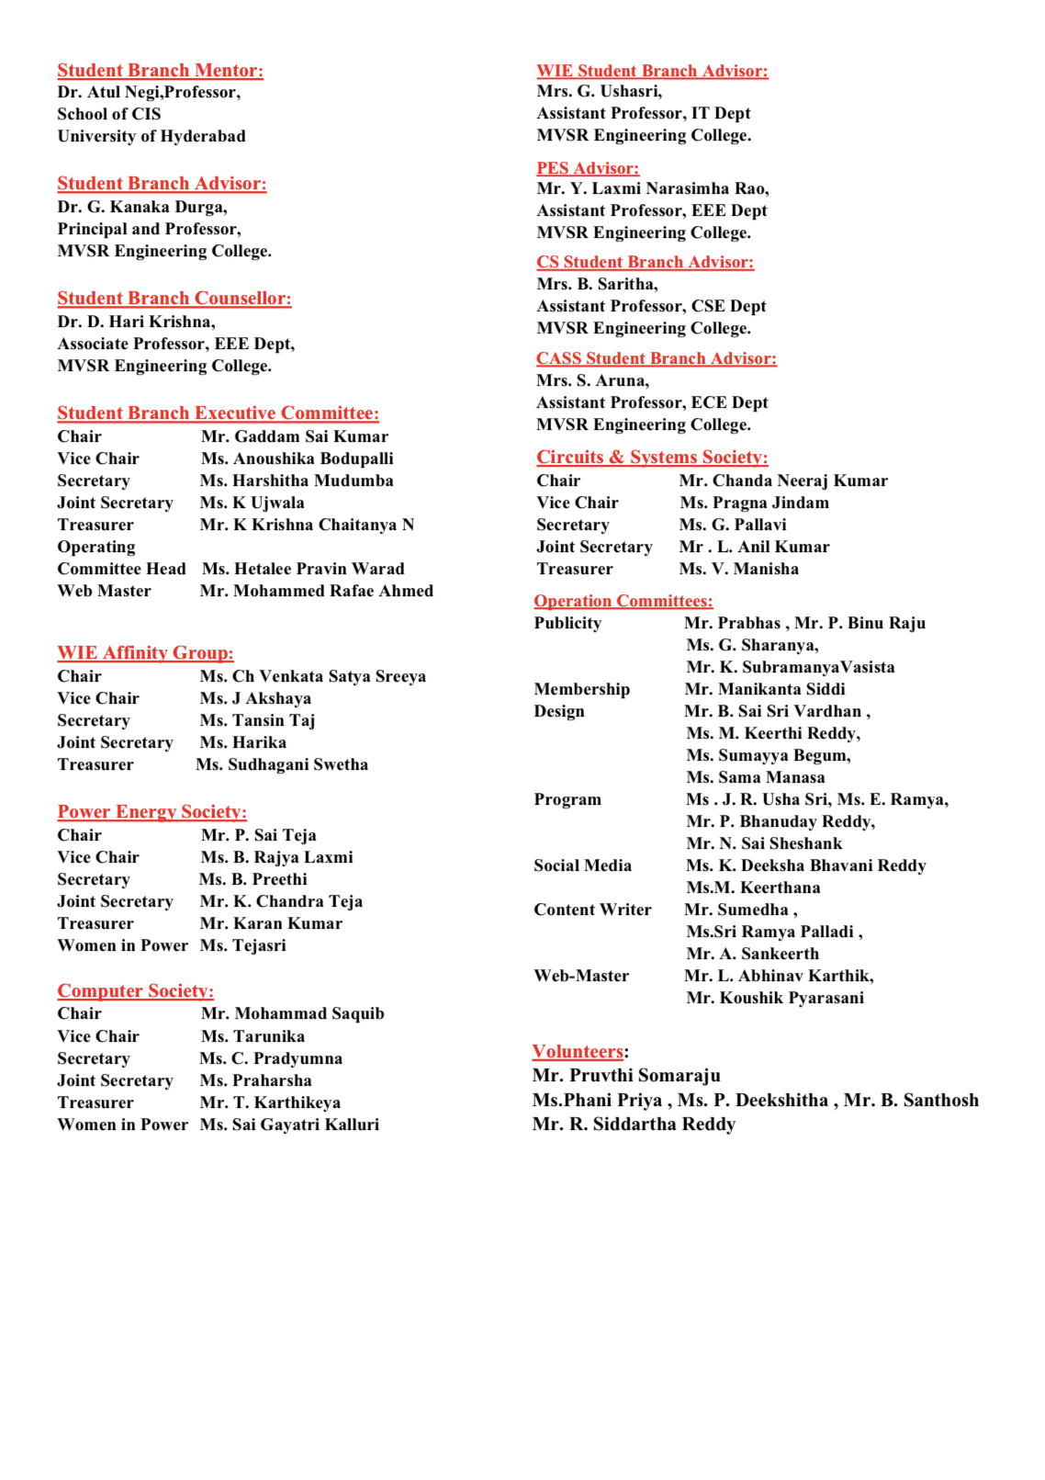

Session Details:

Date: 15th July, 2023

Timings: 2 PM - 4 PM

No. of Attendees: 39

The meeting commenced with Mr. G. Sai Kumar, Chairperson of IEEE MVSR SB, and Ms. B. Anoushika, Vice Chairperson of IEEE MVSR SB, extending a warm welcome to all the present members. The newly selected Executive Committee members introduced themselves, starting with the Main Executive Committee, followed by the CS Executive Committee, CASS Executive Committee, PES Executive Committee, WIE Executive Committee, Sensor (Volunteers), and Operation Committee.

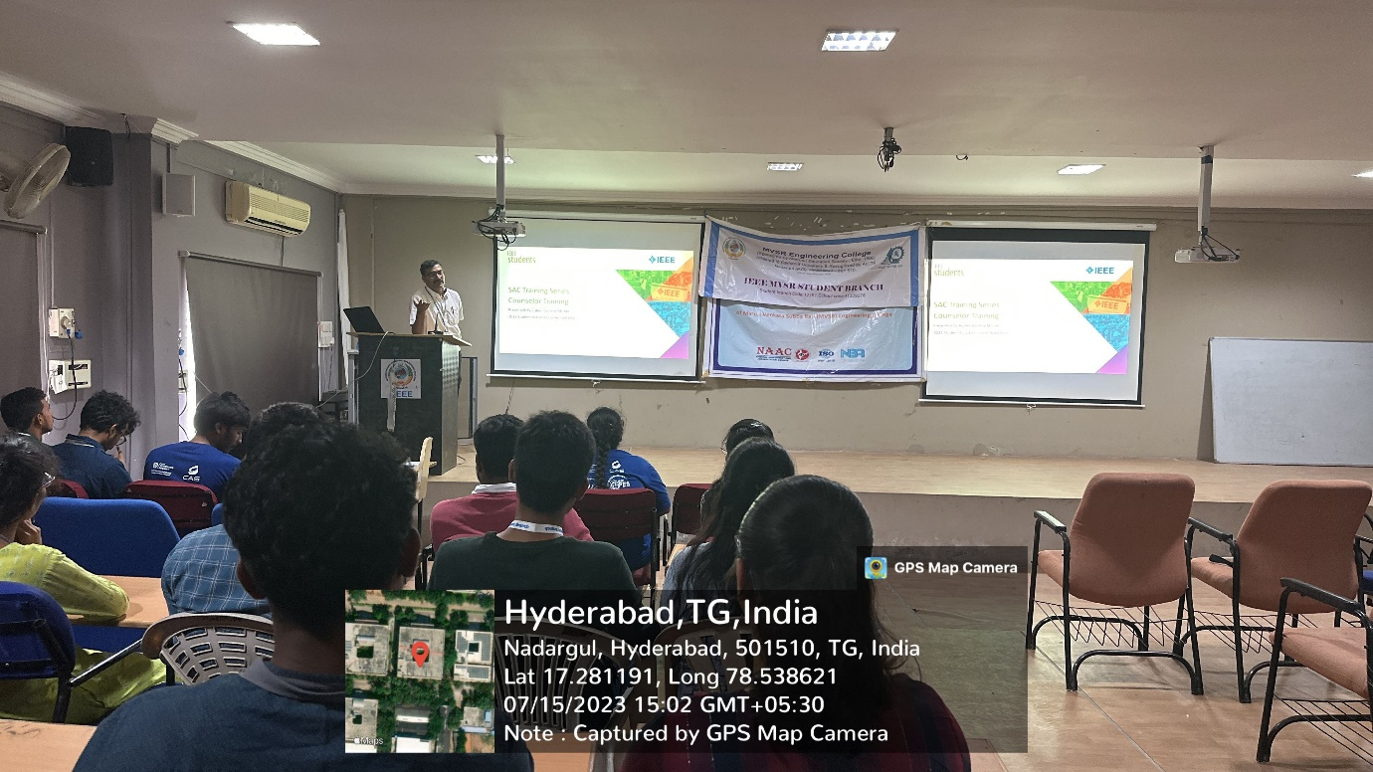
Student Branch Counsellor addressing the ExCom members

Firstly, Dr. D. HariKrishna, the Student Branch Counsellor of IEEE MVSR SB, addressed various key points about IEEE, including the establishment of societies and affinity groups, as well as the branch achievements and awards received by IEEE MVSR, such as the Darrel Chong and IEEE Student Program awards. Moreover, students were encouraged to participate in events like IEEE Xtreme and the IEEE Clap Challenge to gain valuable insights and enhance their technical expertise.
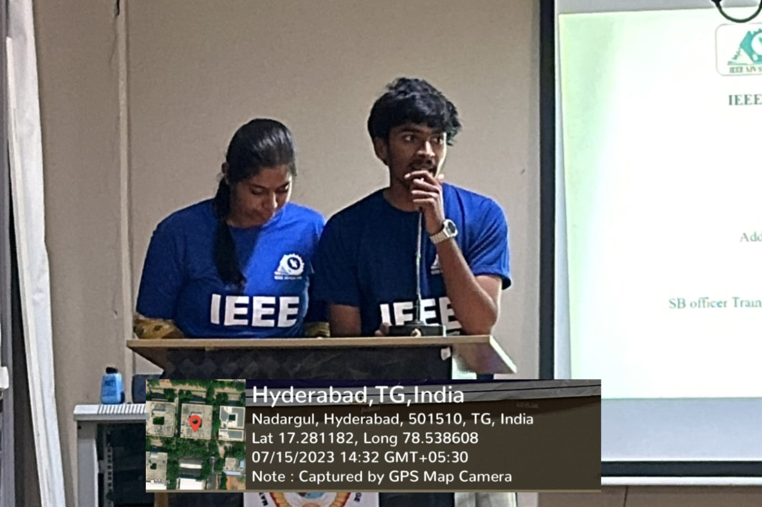
Chair and Vice Chair addressing the gathering

Next, Mr. K. Hemanth, Ex-Chairperson of IEEE MVSR SB, provided an overview of the roles and Responsibilities of each member. The presentation started with the responsibilities of the Chairperson of SB and the Vice Chairperson of SB followed by the Chairpersons, Vice Chairpersons, Secretaries, and Treasurers of all other Committees. He also highlighted the significance of IEEE Xtreme and IEEE Clap Challenge. He emphasized the importance of engaging in Ambassador Roles, which allow students to represent IEEE MVSR SB and contribute to the broader IEEE community.

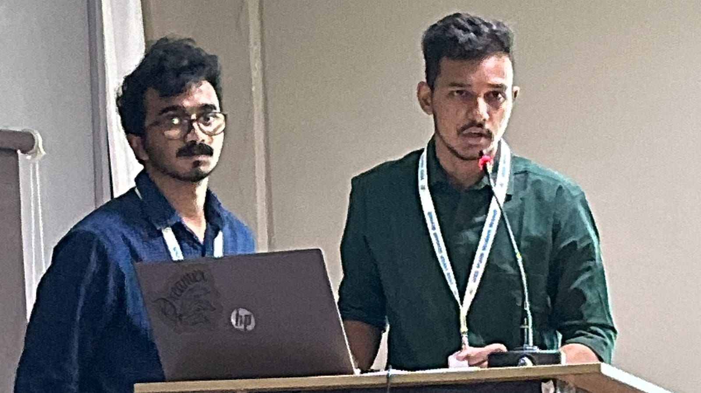
Ex-Chair and Ex-Vice Chair explaining roles & responsibilities

Following this, Mr. K. Naga Seshu, the Ex-Vice Chairperson of IEEE MVSR SB, elaborated on the Roles and Responsibilities of the Operation Committees. He started with the Program Committee and then went on to explain the roles of the Membership Committee Head, Publicity Committee, Social Media Team, Content Writers, Design Committee, and Web Masters. Additionally, he provided guidance on the process and rules for uploading reports in vTools and Data Centre, emphasizing the importance of accurate and timely reporting to maintain transparent records of the organization's activities and progress.

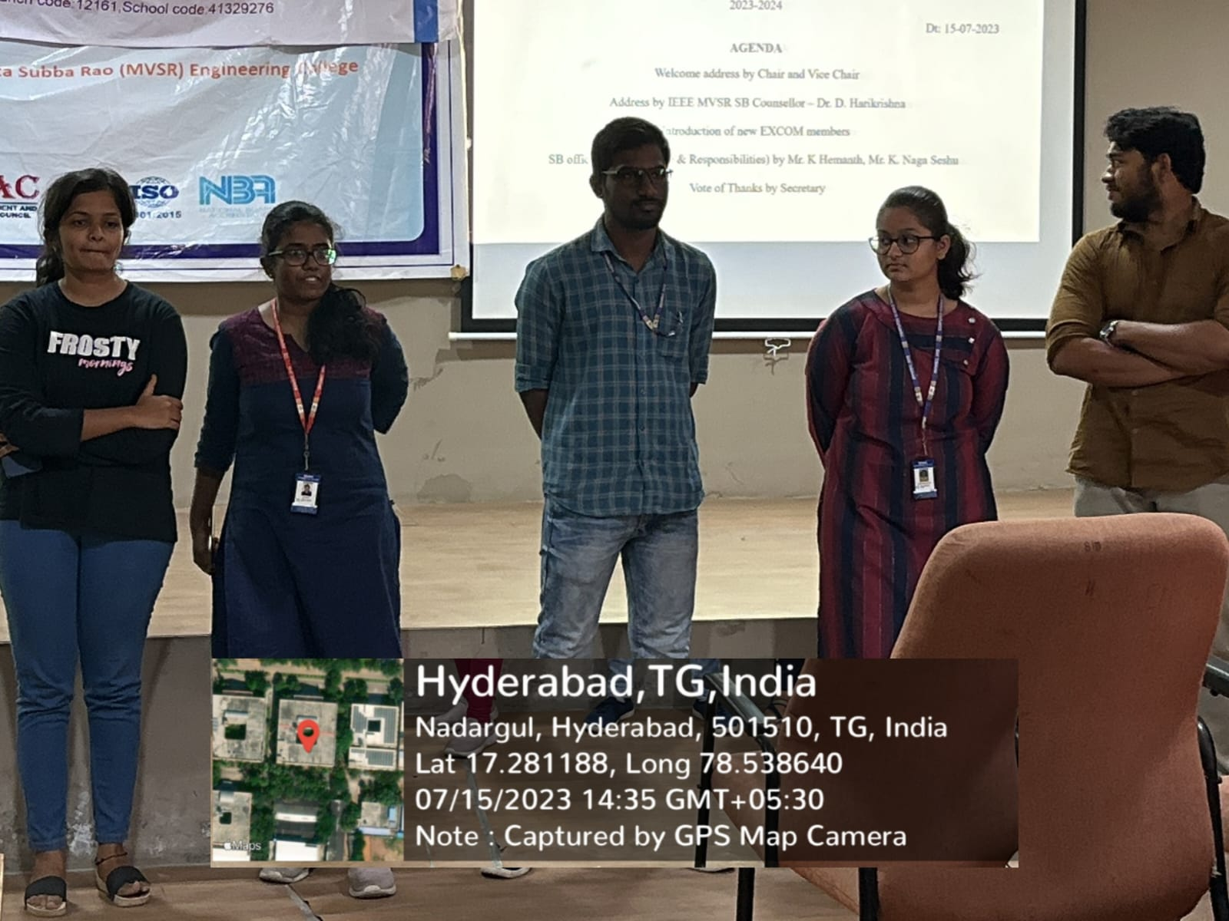
SB Executive Committee members 2023-24

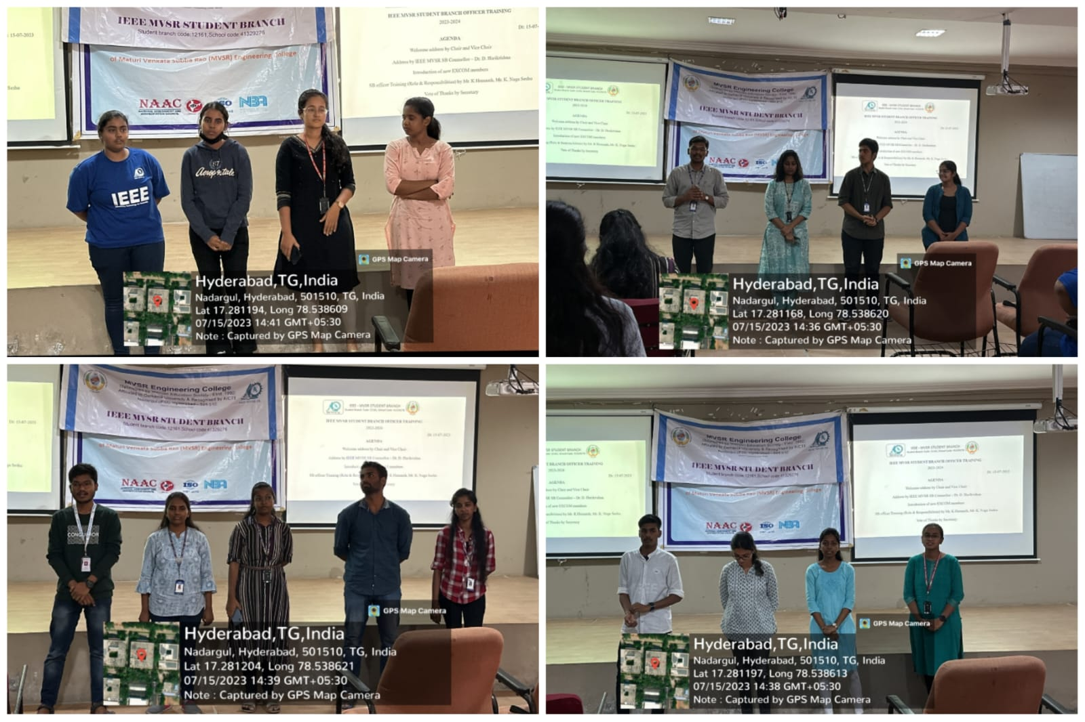
WIE, CS, PES, CASS members
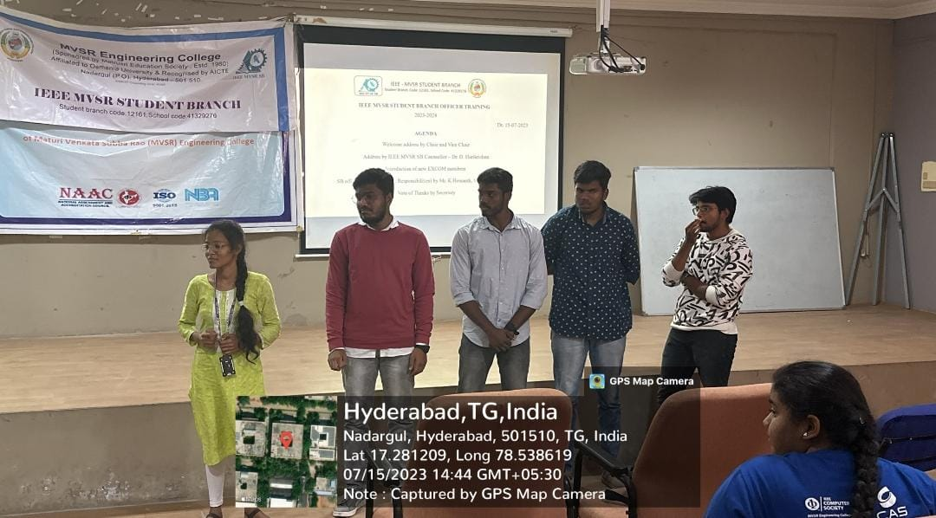
Operation Committee members

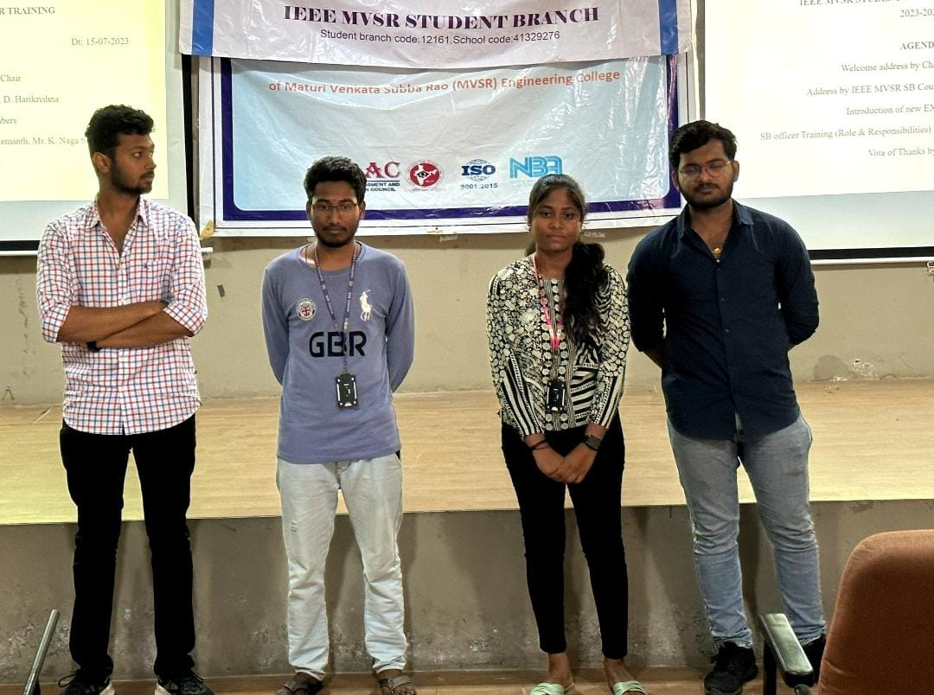
Sensors Volunteers

By providing this comprehensive overview, Ex-Chair and Vice Chair aimed to equip the newly selected ExCom members with a clear understanding of the responsibilities and functions. Lastly, the meeting concluded with Ms. M. Harshitha, the Secretary of IEEE MVSR SB, proposing the vote of thanks.

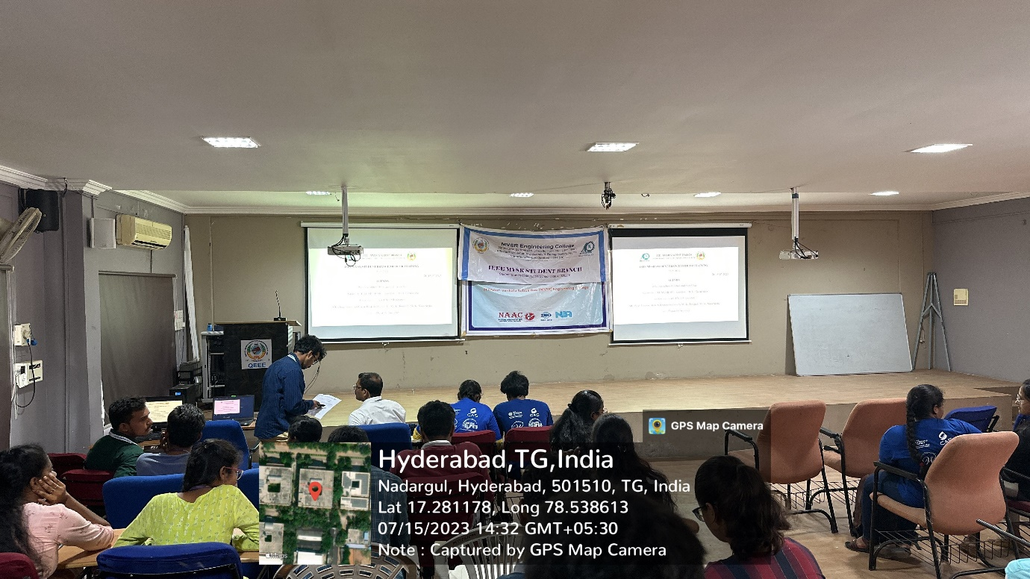
ExCom members in the meeting

List of Attendees:

S.no | Name of the Participant | Roll Number | IEEE ID
 | Dr. D. HariKrishna | Faculty
 | Hemanth | 2451-19-735-118
 | Naga Seshu | 2451-19-734-309
 | Hareen | 2451-19-733-041
 | Gautham Purohit | 2451-19-735-121
 | B.Preethi | 2451-21-734-304 | NA
 | Harshitha Mudumba | 2451-20-735-063 | 98194561
 | Ponugoti Harika | 2451-21-737-194 | 99229064
 | Puram SaiTeja | 2451-20-734-316 | 98610543
 | K. Subrahmanya Vasista | 2451-21-734-071 | 99450211
 | Karan Krishna Kumar | 2451-20-734-040 | 98873400
 | Sudhagani Swetha | 2451-20-734-060 | 99241090
 | Pruthvi Somaraju | 2451-20-735-062 | 98708642
 | Ch Venkata Satya Sreeya | 2451-20-737-151 | 97488096
 | Dusari Teja Sri | 2451-20-734-303 | 98935003
 | Pragna Jindam | 2451-20-735-080 | 98194494
 | D Mohammad Saquib | 2451-20-733-132 | 97496648
 | Chanda Neeraj Kumar | 2451-20-735-119 | 98194538
 | Koushik Pyarasani | 2451-21-733-083 | 99228518
 | P Binu raju | 2451-21-735-048 | 99469450
 | Santhosh Bonagiri | 2451-20-734-004 | NA
 | Ramya Edla | 2451-20-734-069 | NA
 | Gaddam Sai Kumar | 2451-20-735-069 | 98196838
 | Puttam Deekshitha | 2451-20-735-071 | 99225055
 | V Manisha | 2451-20-735-309 | 98197389
 | G. Pallavi | 2451-21-735-102 | 99295467
 | Siddartha Reddy Rikkala | 2451-20-735-116 | 99494252
 | N Krishna Chaitanya | 2421-20-734-052 | 97520855
 | K Ujwala | 2451-20-737-148 | 97508428
 | Anoushika Boddupalli | 2451-20-733-037 | 98196593
 | N. Sai Shashank | 2451-20-734-311 | 98935065
 | Bandari Sai Sri Vardhan | 2451-20-732-103 | 99237169
 | Akshaya Jureddy | 2451-20-735-064 | 99216652
 | B. Rajyalaxmi | 2451-20-734-033 | 97501899
 | Chacham Pradyumna | 2451-21-733-066 | 99228779
 | Manikanta Siddi | 2451-21-735-007 | 99454271
 | P Bhanodaya reddy | 2451-20-735-105 | 99494661
 | Hetalee Pravin Warad | 2451-20-733-165 | 97520755
 | Karan Krishna Kumar | 2451-20-734-040 | 98873400

Reported by:
IEEE MVSR SB

